Cloud Enterprises Lab

Lab Assignment -1

Q1.

Output

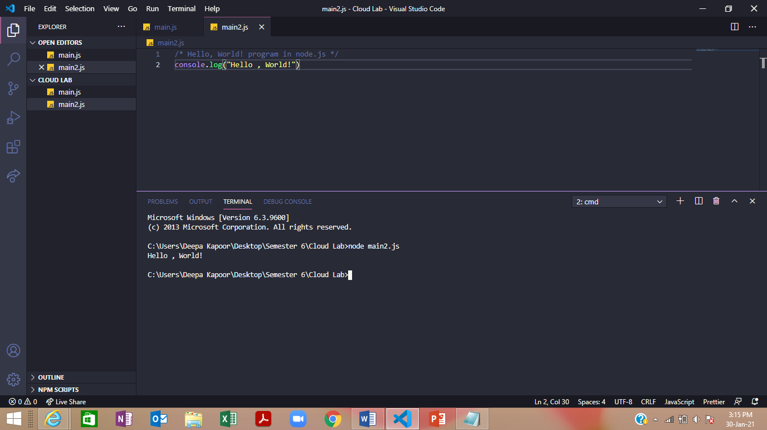

Q2.

Output

